REST - Country Web Service

Write a REST service that returns India country details in the earlier created  
spring learn application.

URL: /country  
 Controller: com.cognizant.spring-learn.controller.CountryController  
 Method Annotation: @RequestMapping  
 Method Name: getCountryIndia()  
 Method Implementation: Load India bean from spring xml configuration and return  
 Sample Request: <http://localhost:8083/country>

Step 1: Create the **CountryController class** under controller package.

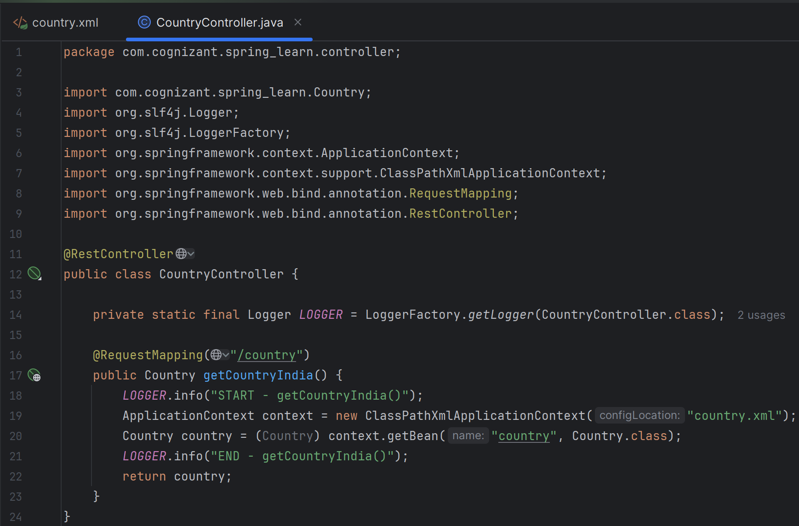The above class :

▪ Loads **country** bean (from **country.xml , was** made in previous task “Hello world Restful web service”) using **ClassPathXmlApplicationContext**

**▪ Returns** the **Country** object directly

▪ Because it’s inside a @RestController, **Spring automatically converts it to JSON** using Jackson (included by default with Spring Boot).

**Output** in **Postman**:



